**LAB Assignment 1:**

**Fa20-bcs-151**

**Aamna Zahid**

**Section: C**

**Sub. To: Mam Anum**

Roll #1 **Outer membrane protein A**

**Q1:**

Find its interacting partners and make a list of them. Also, explain their partners who are co-expressing.

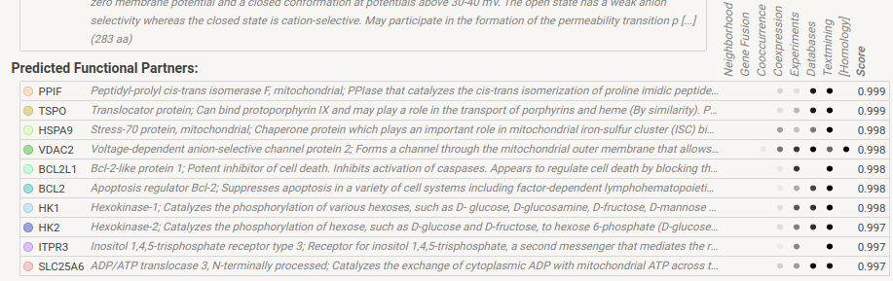

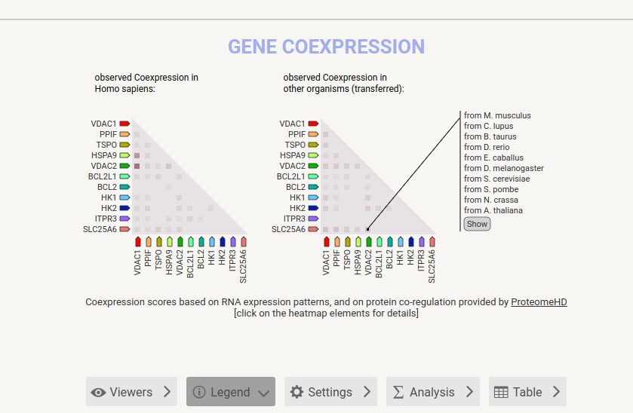

**Q2:**

Find the structure of your assigned protein if any 3D structure is predicted already. And provide its structure details which you know about it?

Do its Alignment by using BLAST

Also, align these two given gene sequences in pairwise alignment by using an appropriate tool.

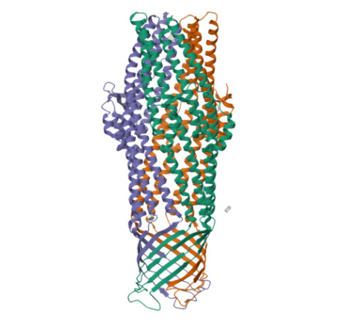Structure:

Structure Details

